**Lab 1:**

**A)Ceaser Cipher output:**

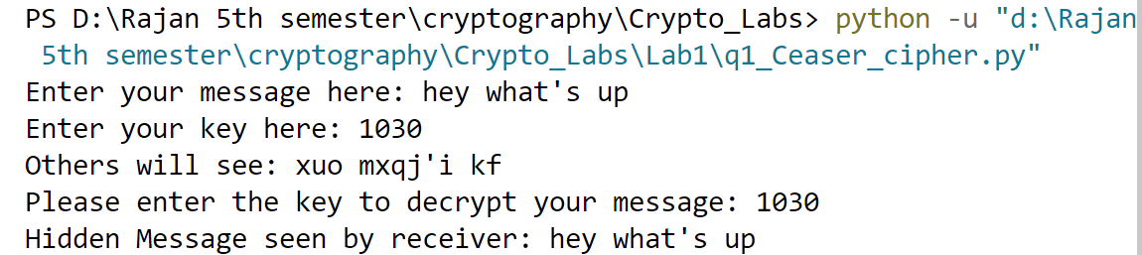

**B) Hill Cipher output:**

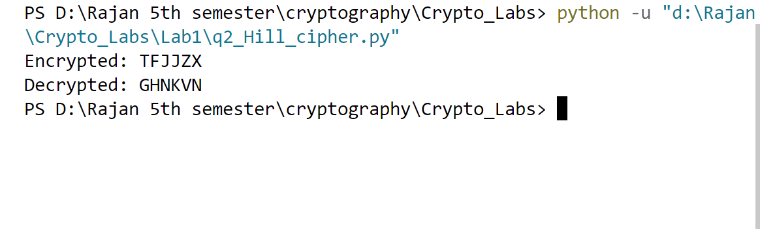

**Lab 2:**

**A) Vigenere Cipher Output:**

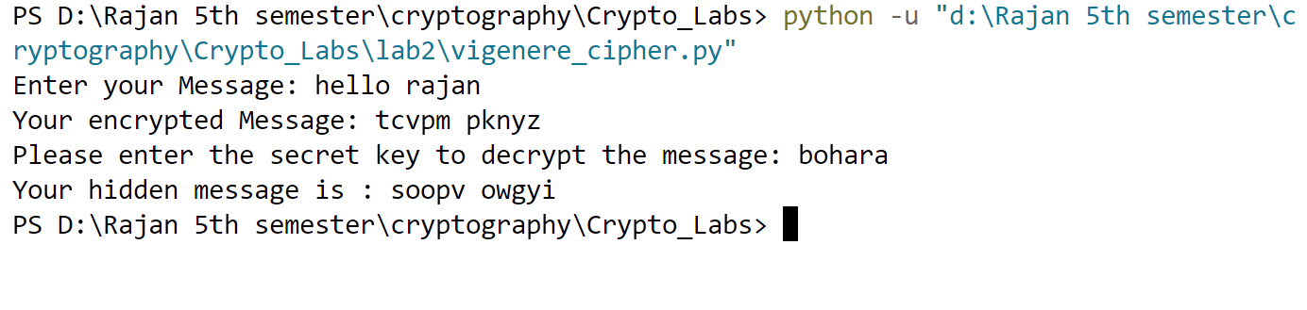

**B) Playfair Cipher Output:**

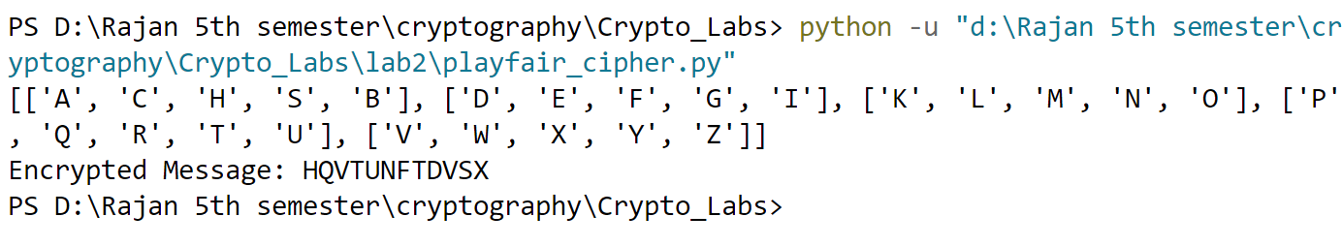

**Lab 3:**

**Rail Fence Cipher Output:**

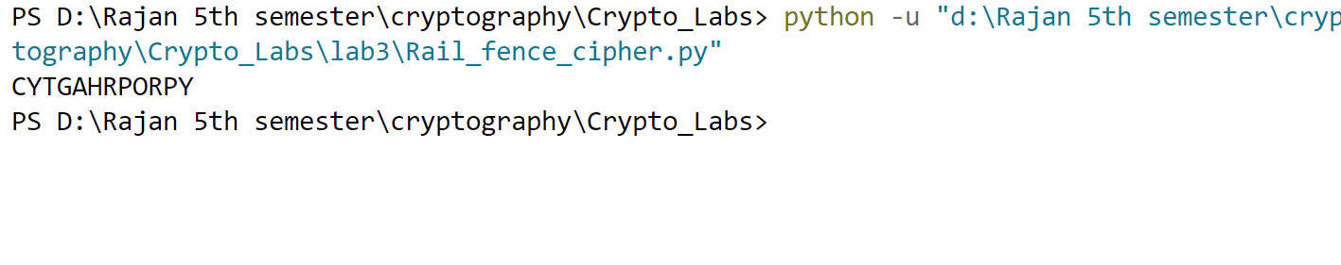

**Lab 4:**

**DES Output:**

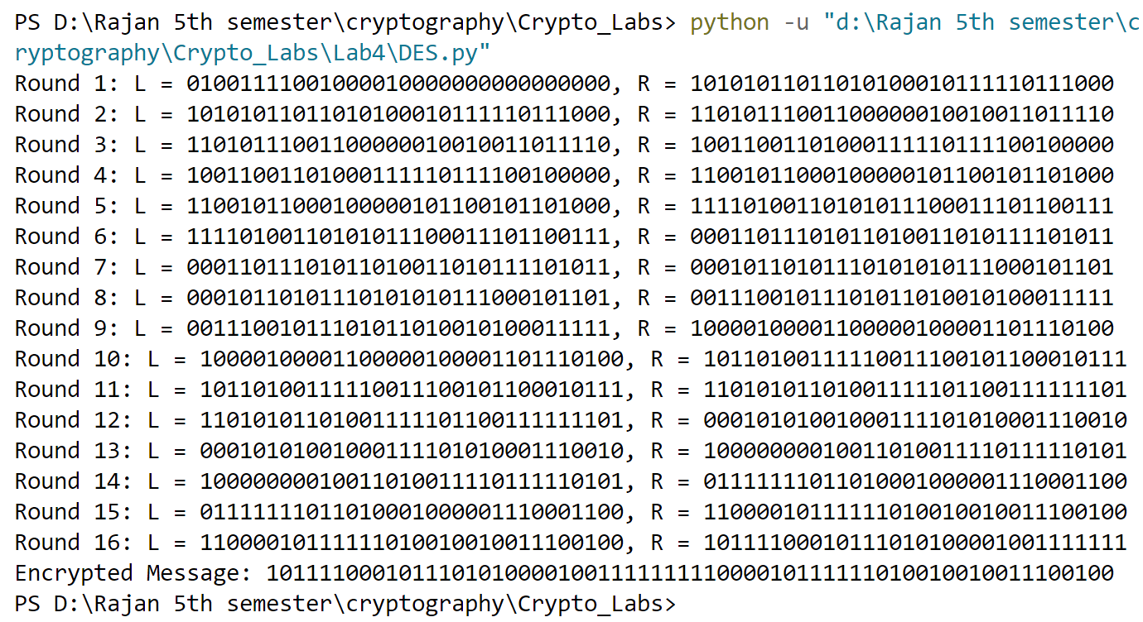

**Lab 5 Output:**

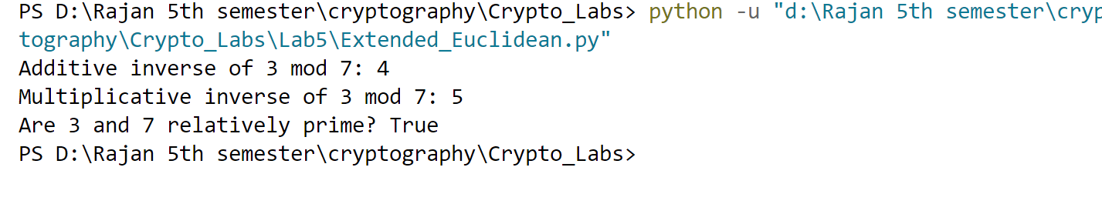

**Lab 6 Output:**

